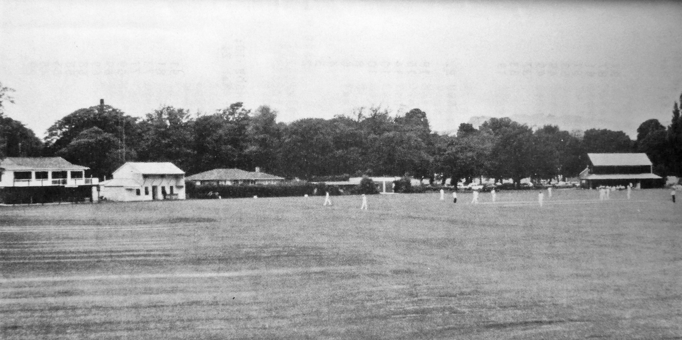

**Hagley Park 1988 club cricket**